GitHub Repo Update Barath S Sundar

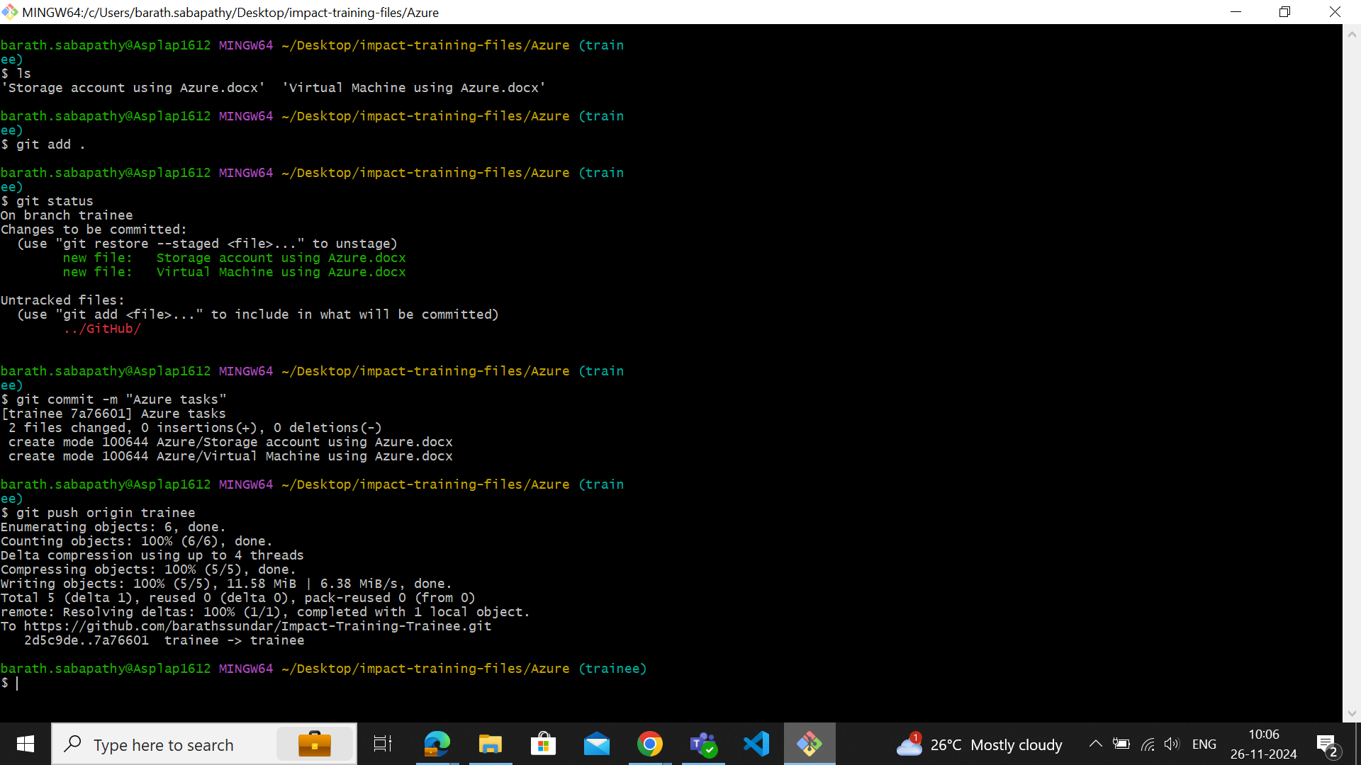

-> ls – list

-> git add . - adds all files

-> git status – status of the files

-> git commit –m “message to be displayed”

-> git push origin location